UNIT-III
Chapter-1
DESIGN CONCEPTS AND PRINCIPLES

Introduction: The designer's goal is to produce a model or representation of an entity that will later be built.
There are two major phases to any design process:
1. Diversification
2. Convergence.
Diversification is the acquisition of a repertoire of alternatives.
The raw material of design: components, component solutions, and knowledge, all contained in catalogs, textbooks, and the mind.
During convergence, the designer chooses and combines appropriate elements from this repertoire to meet the design objectives, as stated in the requirements document and as agreed to by the customer.
The second phase is the gradual elimination of all but one particular configuration of components, and thus the creation of the final product.
1.1 QUICK LOOK
1.1.1 What is it?
Design is a meaningful engineering representation of something that is to be built.
It can be traced to a customer’s requirements and at the same time assessed for quality against a set of predefined criteria for “good” design.
In the software engineering context, design focuses on four major areas of concern: data, architecture, interfaces, and components.
1.1.2 Who does it?
Software engineers design computer based systems, but the skills required at each level of design work are different.
- At the data and architectural level, design focuses on patterns as they apply to the application to be built.
- At the interface level, human ergonomics often dictate our design approach.
- At the component level, a “programming approach” leads us to effective data and procedural designs.
1.1.3 Why is it important?
You wouldn’t attempt to build a house without a blueprint, would you? You’d risk confusion, errors, a floor plan that didn’t make sense, windows and doors in the wrong place . . . a mess.
Computer software is considerably more complex than a house; hence, we need a blueprint— the design.
1.1.4 What are the steps?
Design begins with the requirements model. We work to transform this model into four levels of design detail: the data structure, the system architecture, the interface representation, and the component level detail.
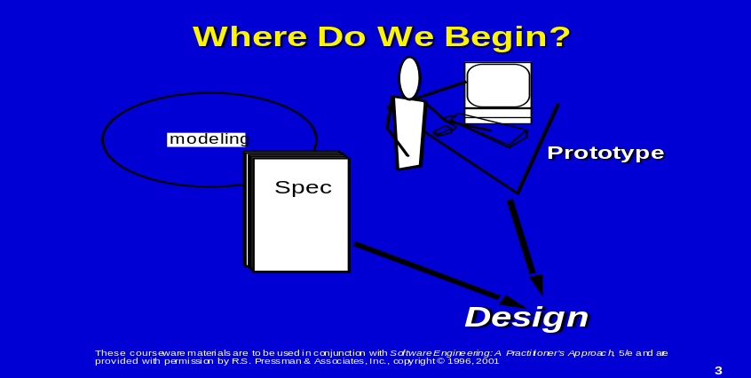

1.1.5 What is the work product?
Ultimately, a Design Specification is produced. The specification is composed of the design models that describe data, architecture, interfaces, components. Each is a work product of the design process.
1.1.6 How do I ensure that I’ve done it right? i.e completed.
At each stage, software design work products are reviewed for clarity, correctness, completeness, consistency with the requirements and with one another.
- Software design methodologies lack the depth, flexibility, and quantitative nature that are normally associated with more classical engineering design disciplines.
- However, methods for software design do exist, criteria for design quality are available, and design notation can be applied.
1.2 SOFTWARE DESIGN AND SOFTWARE ENGINEERING
Software design sits at the technical kernel of software engineering and is applied regardless of the software process model that is used.
Beginning once software requirements have been analyzed and specified, software design is the first of three technical activities—design, code generation, and test—that are required to build and verify the software.
Each activity transforms information in a manner that ultimately results in validated computer software.
Each of the elements of the analysis model provides information that is necessary to create the four design models required for a complete specification of design.
The flow of information during software design is illustrated in Figure
Software requirements, manifested by the data, functional, and behavioral models, feed the design task.
Using one of a number of design methods, the design task produces a data design, an architectural design, an interface design, a component design.
The data design transforms the information domain model created during analysis into the data structures that will be required to implement the software.
The data objects and relationships defined in the entity relationship diagram and the detailed data content depicted in the data dictionary provide the basis for the data design activity.
Part of data design may occur in conjunction with the design of software architecture.
More detailed data design occurs as each software component is designed.
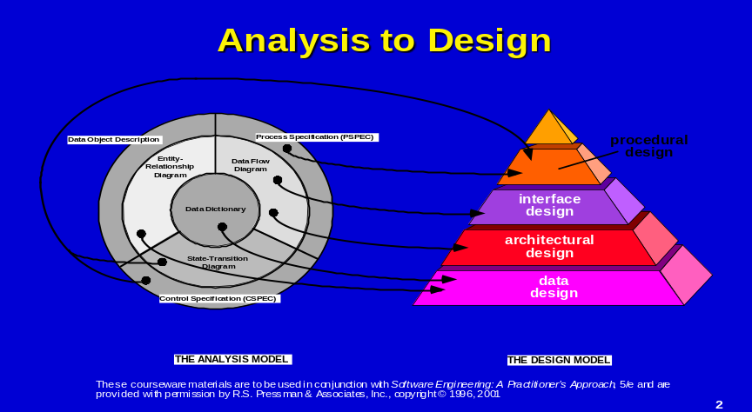
FIGURE 1 Translating the analysis model into a software design
The architectural design defines the relationship between major structural elements of the software, the “design patterns” that can be used to achieve the requirements that have been defined for the system, and the constraints that affect the way in which architectural design patterns can be applied.
The architectural design representation— the framework of a computer-based system can be derived from the system specification, the analysis model, the interaction of subsystems defined within the analysis model.
The interface design describes how the software communicates within itself, with systems that inter-operate with it, and with humans who use it.
An interface implies a flow of information (e.g., data and/or control) and a specific type of behavior.
Therefore, data and control flow diagrams provide much of the information required for interface design.
The component-level design transforms structural elements of the software architecture into a procedural description of software components.
Information obtained from the PSPEC, CSPEC, and STD serve as the basis for component design.
During design we make decisions that will ultimately affect the success of software construction and, as important, the ease with which software can be maintained.
1.2.1 But why is design so important?
The importance of software design can be stated with a single word—quality.
- Design is the place where quality is fostered in software engineering.
- Design provides us with representations of software that can be assessed for quality.
- Design is the only way that we can accurately translate a customer's requirements into a finished software product or system.
- Software design serves as the foundation for all the software engineering and software support steps that follow.
- Without design, we risk building an unstable system—one that will fail when small changes are made; one that may be difficult to test; one whose quality cannot be assessed until late in the software process, when time is short and many dollars have already been spent.
1.2.2 THE DESIGN PROCESS
Software design is an iterative process through which requirements are translated into a “blueprint” for constructing the software.
Initially, the blueprint depicts a holistic view of software.
That is, the design is represented at a high level of abstraction— a level that can be directly traced to the specific system objective and more detailed data, functional, and behavioral requirements.
As design iterations occur, subsequent refinement leads to design representations at much lower levels of abstraction.
These can still be traced to requirements, but the connection is more subtle.
1.2.3 Design and Software Quality
Throughout the design process, the quality of the evolving design is assessed with a series of formal technical reviews or design walkthroughs
the three characteristics that serve as a guide for the evaluation of a good design:
- The design must implement all of the explicit requirements contained in the analysis model, and it must accommodate all of the implicit requirements desired by the customer.
- The design must be a readable, understandable guide for those who generate code and for those who test and subsequently support the software.
- The design should provide a complete picture of the software, addressing the data, functional, and behavioral domains from an implementation perspective.
Each of these characteristics is actually a goal of the design process.
But how is each of these goals achieved?
In order to evaluate the quality of a design representation, we must establish technical criteria for good design.
For the time being, we present the following guidelines:
- A design should exhibit an architectural structure that
(a) has been created using recognizable design patterns,
(b) is composed of components that exhibit good design characteristics
(c) can be implemented in an evolutionary fashion, thereby facilitating implementation and testing.
- A design should be modular; that is, the software should be logically partitioned into elements that perform specific functions and sub functions.
- A design should contain distinct representations of data, architecture, interfaces, and components (modules).
- A design should lead to data structures that are appropriate for the objects to be implemented and are drawn from recognizable data patterns.
- A design should lead to components that exhibit independent functional characteristics.
- A design should lead to interfaces that reduce the complexity of connections between modules and with the external environment.
- A design should be derived using a repeatable method that is driven by information obtained during software requirements analysis.
1.2.4 The Evolution of Software Design
The evolution of software design is a continuing process that has spanned the past four decades.
Early design work concentrated on criteria for the development of modular programs and methods for refining software structures in a top-down manner .
Procedural aspects of design definition evolved into a philosophy called structured programming.
Later work proposed methods for the translation of data flow or data structure into a design definition.
Newer design approaches proposed an object-oriented approach to design derivation.
Today, the emphasis in software design has been on software architecture and the design patterns that can be used to implement software architectures .
All of these methods have a number of common characteristics:
(1) a mechanism for the translation of analysis model into a design representation,
(2) a notation for representing functional components and their interfaces,
(3) heuristics for refinement and partitioning,
(4) guidelines for quality assessment.
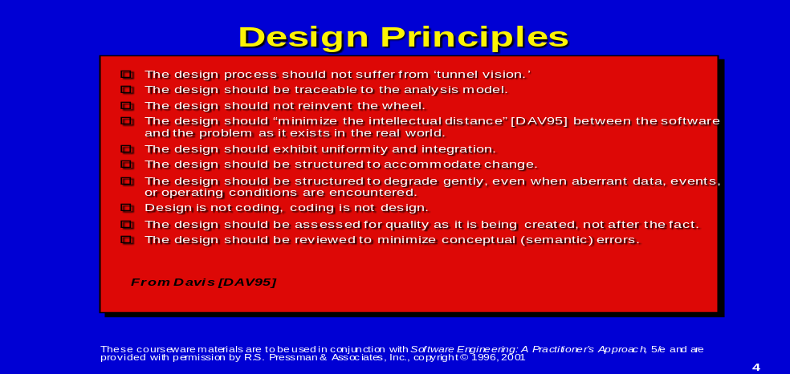

1.3 DESIGN PRINCIPLES
Software design is both a process and a model.
design process: The design process is a sequence of steps that enable the designer to describe all aspects of the software to be built.
- It is important to note, however, that the design process is not simply a cookbook.
- Creative skill, past experience, a sense of what makes “good” software, and an overall commitment to quality are critical success factors for a competent design.
design model: The design model is the equivalent of an architect’s plans for a house.
- It begins by representing the totality of the thing to be built (e.g., a three-dimensional rendering of the house) and slowly refines the thing to provide guidance for constructing each detail (e.g., the plumbing layout).
- Similarly, the design model that is created for software provides a variety of different views of the computer software.
Principles for software design:
- The design process should not suffer from “tunnel vision.”
A good designer should consider alternative approaches, judging each approach based on the requirements of the problem, the resources available to do the job, and the design concepts .
- The design should be traceable to the analysis model.
Because a single element of the design model often traces to multiple requirements, it is necessary to have a means for tracking how requirements have been satisfied by the design model.
- The design should not reinvent the wheel.
Systems are constructed using a set of design patterns, many of which have likely been encountered before.
These patterns should always be chosen as an alternative to reinvention. Time is short and resources are limited
Design time should be invested in representing truly new ideas and integrating those patterns that already exist.
- The design should “minimize the intellectual distance” between the software and the problem as it exists in the real world.
That is, the structure of the software design should (whenever possible) mimic the structure of the problem domain.
- The design should exhibit uniformity and integration.
A design is uniform if it appears that one person developed the entire thing.
Rules of style and format should be defined for a design team before design work begins.
A design is integrated if care is taken in defining interfaces between design components.
- The design should be structured to accommodate change. The design concepts enable a design to achieve this principle.
- The design should be structured to degrade gently, even when aberrant data, events, or operating conditions are encountered.
Well designed software must accommodate unusual circumstances, and if it must terminate processing, do so in a graceful manner.
- Design is not coding, coding is not design.
Even when detailed procedural designs are created for program components, the level of abstraction of the design model is higher than source code.
The only design decisions made at the coding level address the small implementation details that enable the procedural design to be coded.
- The design should be assessed for quality as it is being created, not after the fact.
A variety of design concepts and design measures are available to assist the designer in assessing quality.
- The design should be reviewed to minimize conceptual (semantic) errors. There is sometimes a tendency to focus on minutiae when the design is reviewed, missing the forest for the trees. A design team should ensure that major conceptual elements of the design (omissions, ambiguity, inconsistency) have been addressed before worrying about the syntax of the design model. The software engineer must create a design that exhibits both external and internal quality factors
External quality factors are those properties of the software that can be readily observed by users (e.g., speed, reliability, correctness, usability).
Internal quality factors are of importance to software engineers. They lead to a high-quality design from the technical perspective. To achieve internal quality factors, the designer must understand basic design concepts.
1.4 DESIGN CONCEPTS
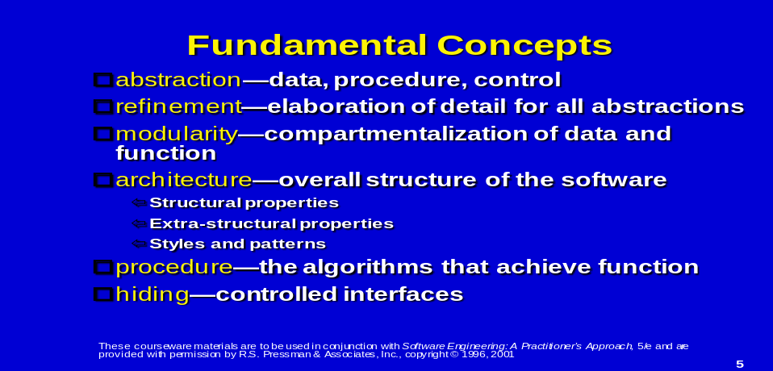
A set of fundamental software design concepts has evolved over the past four decades. Each helps the software engineer to answer the following questions:
- What criteria can be used to partition software into individual components?
- How function or data is structure detail separated from a conceptual representation of the software?
- What uniform criteria define the technical quality of a software design?
1.4.1 Abstraction
When we consider a modular solution to any problem, many levels of abstraction can be posed.
At the highest level of abstraction, a solution is stated in broad terms using the language of the problem environment.
- At lower levels of abstraction, a more procedural orientation is taken. Problem-oriented terminology is coupled with implementation- oriented terminology in an effort to state a solution.
- At the lowest level of abstraction, the solution is stated in a manner that can be directly implemented.
- Each step in the software process is a refinement in the level of abstraction of the software solution.
- As we move through the design process, the level of abstraction is reduced. Finally, the lowest level of abstraction is reached when source code is generated.
- As we move through different levels of abstraction, we work to create procedural and data abstractions.
- A procedural abstraction is a named sequence of instructions that has a specific and limited function.
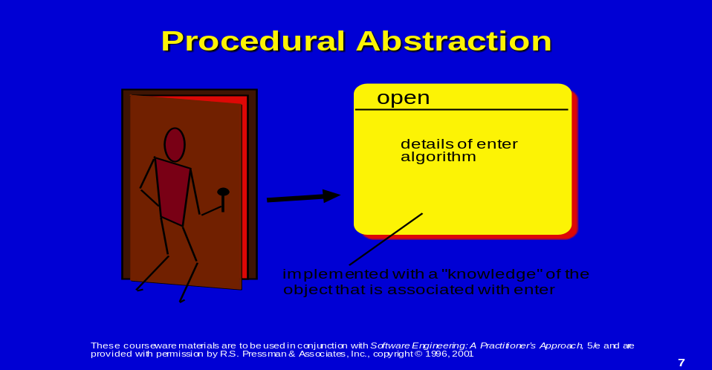
- An example of a procedural abstraction would be the word open for a door. Open implies a long sequence of procedural steps (e.g., walk to the door, reach out and grasp knob, turn knob and pull door, step away from moving door, etc.).
- A data abstraction is a named collection of data that describes a data object . (*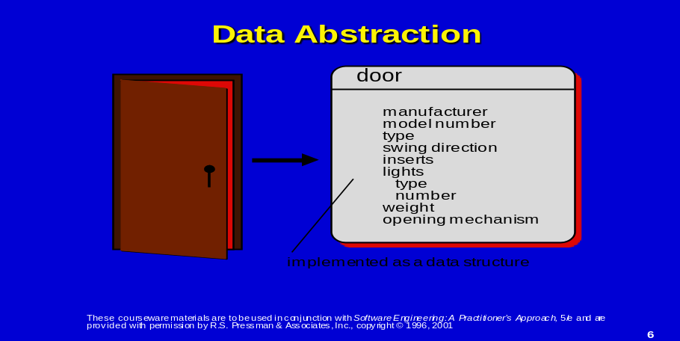
1.4.2 Refinement
Stepwise refinement is a top-down design strategy ,A program is developed by successively refining levels of procedural detail. (* ANIMATION REQUIRED *)
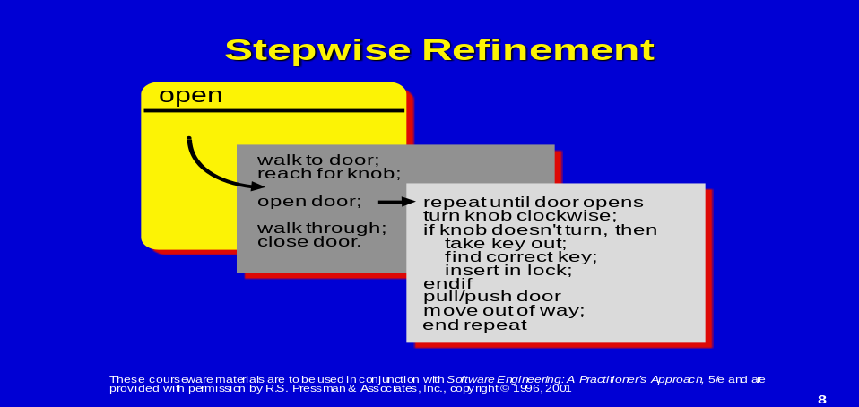
A hierarchy is developed by decomposing a macroscopic statement of function (a procedural abstraction) in a stepwise fashion until programming language statements are reached.
In each step of the refinement, one or several instructions of the given program are decomposed into more detailed instructions.
This successive decomposition or refinement of specifications terminates when all instructions are expressed in terms of any underlying computer or programming language . . .
As tasks are refined, so the data may have to be refined, decomposed, or structured, and it is natural to refine the program and the data specifications in parallel.
Every refinement step implies some design decisions. It is important that the programmer be aware of the underlying criteria (for design decisions) and of the existence of alternative solutions .
The process of program refinement is analogous to the process of refinement and partitioning that is used during requirements analysis. The difference is in the level of implementation detail that is considered, not the approach.
Refinement is actually a process of elaboration.
We begin with a statement of function (or description of information) that is defined at a high level of abstraction.
That is, the statement describes function or information conceptually but provides no information about the internal workings of the function or the internal structure of the information.
Refinement causes the designer to elaborate on the original statement, providing more and more detail as each successive refinement (elaboration) occurs.
Abstraction and refinement are complementary concepts.
Abstraction enables a designer to specify procedure and data and yet suppress low-level details.
Refinement helps the designer to reveal low-level details as design progresses. Both concepts aid the designer in creating a complete design model as the design evolves.
1.4.3 Modularity
The concept of modularity in computer software has been espoused for almost five decades. Modularity: software is divided into separately named and addressable components, often called modules, that are integrated to satisfy problem requirements.
It has been stated that "modularity is the single attribute of software that allows a program to be intellectually manageable".
Monolithic software (i.e., a large program composed of a single module) cannot be easily grasped by a reader. The number of control paths, span of reference, number of variables, and overall complexity would make understanding close to impossible. 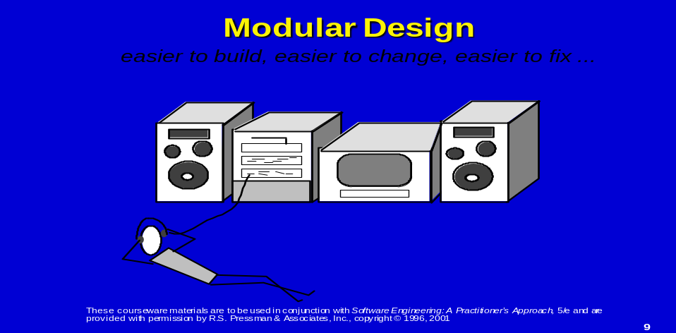
Ex: To illustrate this point, consider the following argument based on observations of human problem solving.
Let Complexity(x) be a function that defines the perceived complexity of a problem x, and
Effort(x) be a function that defines the effort (in time) required to solve a problem x.
For two problems, p1 and p2,
ifComplexity(p1) > Complexity(p2) →(13-1a) it follows that Effort(p1) > Effort(p2) → (13-1b)
As a general case, this result is intuitively obvious. It does take more time to solve a difficult problem.
Another interesting characteristic has been uncovered through experimentation in human problem solving. That is,
C(p1 + p2) > C(p1) + C(p2) (13-2)
Expression (13-2) implies that the perceived complexity of a problem that combines p1 and p2 is greater than the perceived complexity when each problem is considered separately.
Considering Expression (13-2) and the condition implied by Expressions (13-1), it follows that
E(p1 + p2) > E(p1) + E(p2) (13-3)
This leads to a "divide and conquer" conclusion—it's easier to solve a complex problem when you break it into manageable pieces.
The result expressed in Expression (13-3) has important implications with regard to modularity and software.
It is possible to conclude from Expression (13-3) that, if we subdivide software indefinitely, the effort required to develop it will become negligibly small! Unfortunately, other forces come into play, causing this conclusion to be (sadly) invalid.
Referring to Figure 3.2, the effort (cost) to develop an individual software module does decrease as the total number of modules increases.
Given the same set of requirements, more modules means smaller individual size. However, as the number of modules grows, the effort (cost) associated with integrating the modules also grows.
These characteristics lead to a total cost or effort curve shown in the figure.
There is a number, M, of modules that would result in minimum development cost, but we do not have the necessary sophistication to predict M with assurance.
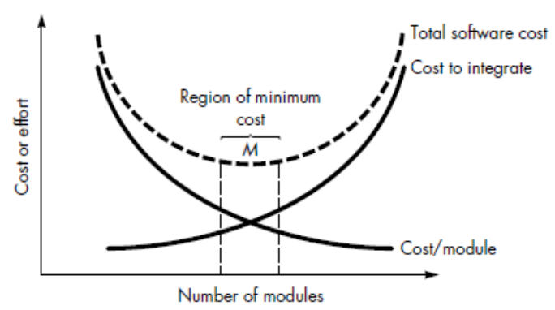
FIGURE 1.2 Modularity and software cost

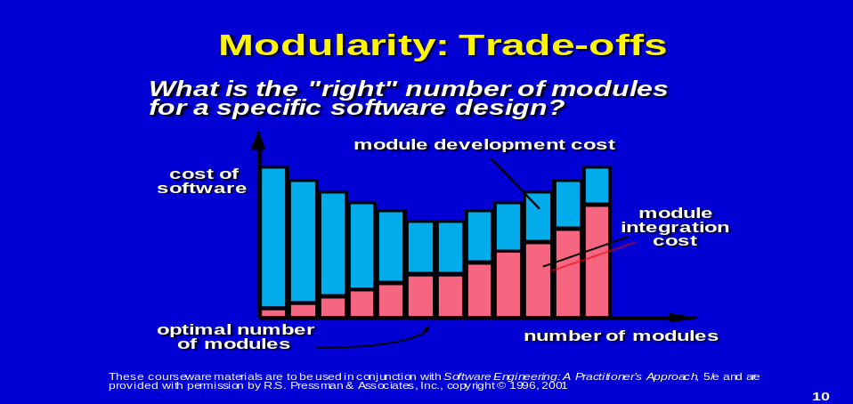
The curves shown in Figure 3.2 do provide useful guidance when modularity is considered. We should modularize, but care should be taken to stay in the area of M of above fig.
Undermodularity or overmodularity should be avoided. (* ANIMATION REQUIRED *)
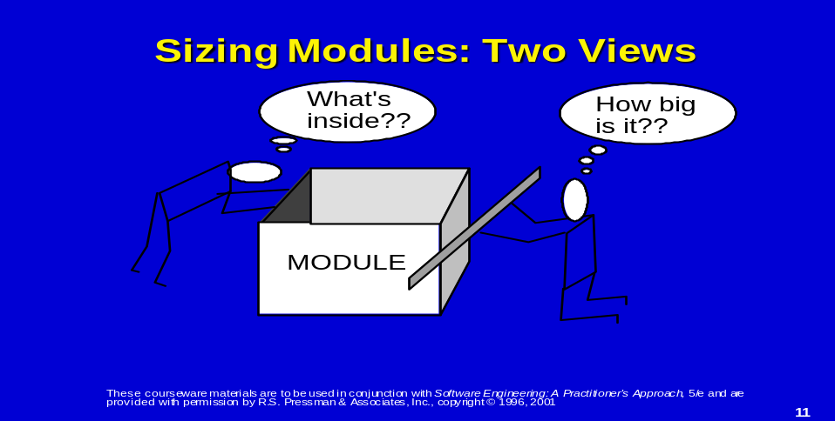
five important criteria that enable us to evaluate a design method with respect to its ability to define an effective modular system:
1.Modular decomposability. If a design method provides a systematic mechanism for decomposing the problem into sub problems, it will reduce the complexity of the overall problem, thereby achieving an effective modular solution.
2.Modular composability. If a design method enables existing (reusable) design components to be assembled into a new system, it will yield a modular solution that does not reinvent the wheel.
3. Modular understandability. If a module can be understood as a standalone unit (without reference to other modules), it will be easier to build and easier to change.
4. Modular continuity. If small changes to the system requirements result in changes to individual modules, rather than systemwide changes, the impact of change-induced side effects will be minimized.
5. Modular protection. If an aberrant condition occurs within a module and its effects are constrained within that module, the impact of error-induced side effects will be minimized.
Finally, it is important to note that a system may be designed modularly, even if its implementation must be "monolithic."
There are situations (e.g., real-time software, embedded software) in which relatively minimal speed and memory overhead introduced by subprograms (i.e., subroutines, procedures) is unacceptable.
In such situations, software can and should be designed with modularity as an overriding philosophy. Code may be developed "in-line."
Although the program source code may not look modular at first glance, the philosophy has been maintained and the program will provide the benefits of a modular system.
1.4.4 Software Architecture
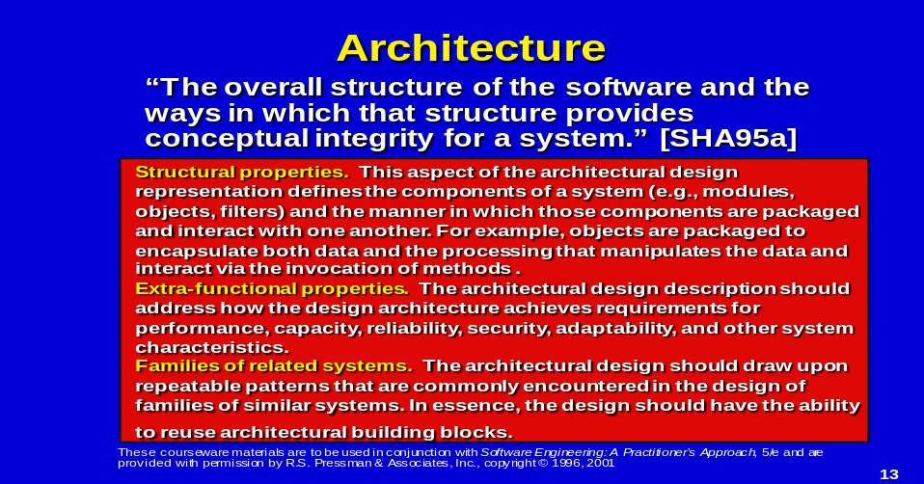
Software architecture alludes to “the overall structure of the software and the ways in which that structure provides conceptual integrity for a system” .
In its simplest form, architecture is the hierarchical structure of program components (modules), the manner in which these components interact and the structure of data that are used by the components.
In a broader sense, however, components can be generalized to represent major system elements and their interactions.
One goal of software design is to derive an architectural rendering of a system.
This rendering serves as a framework from which more detailed design activities are conducted. A set of architectural patterns enable a software engineer to reuse design level concepts.
Architectural design properties:
Structural properties. This aspect of the architectural design representation defines the components of a system (e.g., modules, objects, filters) and the manner in which those components are packaged and interact with one another.
Example: objects are packaged to encapsulate both data and the processing that manipulates the data and interact via the invocation of methods.
Extra-functional properties. The architectural design description should address how the design architecture achieves requirements for performance, capacity, reliability, security, adaptability, and other system characteristics.
Families of related systems. The architectural design should draw upon repeatable patterns that are commonly encountered in the design of families of similar systems. In essence, the design should have the ability to reuse architectural building blocks.
The architectural design can be represented using one or more of a number of different models
Structural models represent architecture as an organized collection of program components.
Framework models increase the level of design abstraction by attempting to identify repeatable architectural design frameworks (patterns) that are encountered in similar types of applications.
Dynamic models address the behavioral aspects of the program architecture, indicating how the structure or system configuration may change as a function of external events.
Process models focus on the design of the business or technical process that the system must accommodate. Finally, functional models can be used to represent the functional hierarchy of a system.
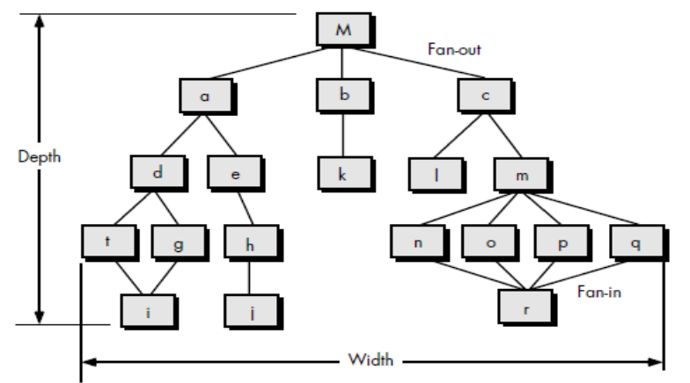
FIGURE 1.3 Structure terminologies for a call and return architectural style
A number of different architectural description languages (ADLs) have been developed to represent these models .
1.4.5 Information Hiding
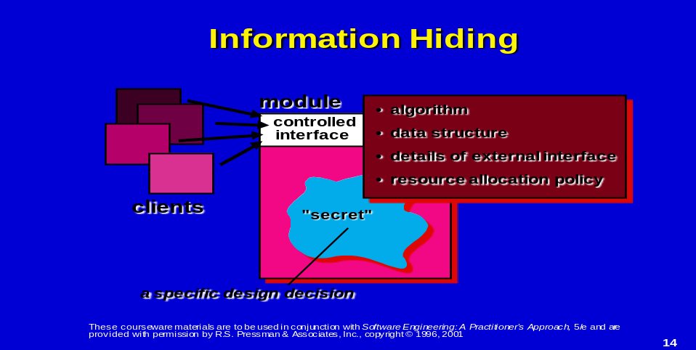
The concept of modularity leads every software designer to a fundamental question:
"How do we decompose a software solution to obtain the best set of modules?"
The principle of information hiding suggests that modules be "characterized by design decisions that (each) hides from all others."
In other words, modules should be specified and designed so that information (procedure and data) contained within a module is inaccessible to other modules that have no need for such information.
Hiding implies that effective modularity can be achieved by defining a set of independent modules that communicate with one another only that information necessary to achieve software function.
Abstraction helps to define the procedural (or informational) entities that make up the software.
Hiding defines and enforces access constraints to both procedural detail within a module and any local data structure used by the module .
The use of information hiding as a design criterion for modular systems provides the greatest benefits when modifications are required during testing and later, during software maintenance.
Because most data and procedure are hidden from other parts of the software, inadvertent errors introduced during modification are less likely to propagate to other locations within the software.
1.4.6 Functional Independence
The concept of functional independence is a direct out growth of modularity and the concepts of abstraction and information hiding
Functional independence is achieved by developing modules with "single-minded" function and an "aversion" to excessive interaction with other modules.
Stated another way, we want to design software so that each module addresses a specific sub function of requirements and has a simple interface when viewed from other parts of the program structure.
It is fair to ask why independence is important. Software with effective modularity, that is, independent modules, is easier to develop because function may be compartmentalized and interfaces are simplified (consider the ramifications when development is conducted by a team).
Independent modules are easier to maintain (and test) because secondary effects caused by design or code modification are limited, error propagation is reduced, and reusable modules are possible.
To summarize, functional independence is a key to good design, and design is the key to software quality.
Independence is measured using two qualitative criteria: cohesion and coupling.
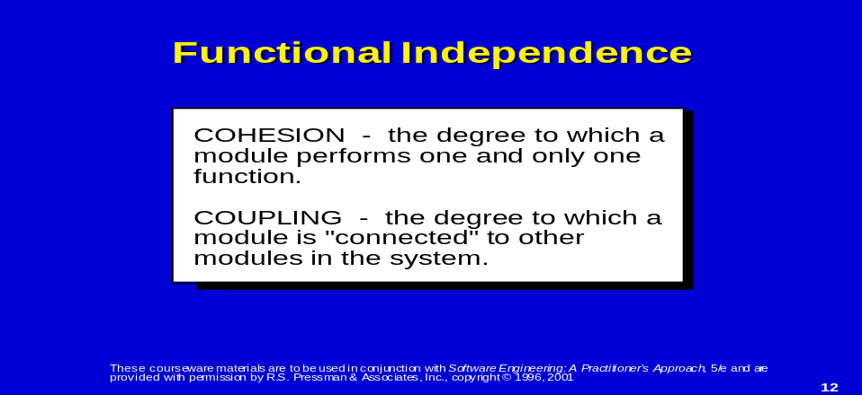
Cohesion is a measure of the relative functional strength of a module.
Coupling is a measure of the relative interdependence among modules.
Cohesion: is a natural extension of the information hiding .
A cohesive module performs a single task within a software procedure, requiring little interaction with procedures being performed in other parts of a program.
Stated simply, a cohesive module should (ideally) do just one thing.
Cohesion may be represented as a "spectrum." We always strive for high cohesion, although the mid-range of the spectrum is often acceptable.
The scale for cohesion is nonlinear. That is, low-end cohesiveness is much "worse" than middle range, which is nearly as "good" as high-end cohesion.
In practice, a designer need not be concerned with categorizing cohesion in a specific module.
Rather, the overall concept should be understood and low levels of cohesion should be avoided when modules are designed.
At the low (undesirable) end of the spectrum, we encounter a module that performs a set of tasks that relate to each other loosely, if at all. Such modules are termed coincidentally cohesive.
A module that performs tasks that are related logically (e.g., a module that produces all output regardless of type) is logically cohesive.
When a module contains tasks that are related by the fact that all must be executed with the same span of time, the module exhibits temporal cohesion.
As an example of low cohesion, consider a module that performs error processing for an engineering analysis package.
The module is called when computed data exceed pre specified bounds.
It performs the following tasks:
- Computes supplementary data based on original computed data,
- Produces an error report (with graphical content) on the user's workstation,
- Performs follow-up calculations requested by the user,
- Updates a database, and
- Enables menu selection for subsequent processing.
Although the preceding tasks are loosely related, each is an independent functional entity that might best be performed as a separate module. Combining the functions into a single module can serve only to increase the likelihood of error propagation when a modification is made to one of its processing tasks.
Moderate levels of cohesion are relatively close to one another in the degree of module independence.
When processing elements of a module are related and must be executed in a specific order, procedural cohesion exists.
When all processing elements concentrate on one area of a data structure, communicational cohesion is present.
High cohesion is characterized by a module that performs one distinct procedural task.
As we have already noted, it is unnecessary to determine the precise level of cohesion.
Rather it is important to strive for high cohesion and recognize low cohesion so that software design can be modified to achieve greater functional independence.
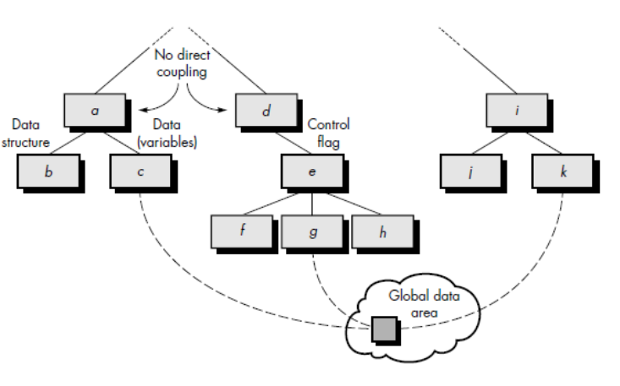
FIGURE 1.4 Types of coupling
Coupling: is a measure of interconnection among modules in a software structure.
Coupling depends on the interface complexity between modules, the point at which entry or reference is made to a module, and what data pass across the interface.
In software design, we strive for lowest possible coupling.
Simple connectivity among modules results in software that is easier to understand and less prone to a "ripple effect", caused when errors occur at one location and propagates through a system.
Figure 1.4 provides examples of different types of module coupling.
Modules a and d are subordinate to different modules. Each is unrelated and therefore no direct coupling occurs. Module c is subordinate to module a and is accessed via a conventional argument list, through which data are passed.
As long as a simple argument list is present (i.e., simple data are passed; a one-to-one correspondence of items exists), low coupling (called data coupling) is exhibited in this portion of structure.
A variation of data coupling, called stamp coupling, is found when a portion of a data structure (rather than simple arguments) is passed via a module interface. This occurs between modules b and a.
At moderate levels, coupling is characterized by passage of control between modules.
Control coupling is very common in most software designs and is shown in Figure 13.6 where a “control flag” (a variable that controls decisions in a subordinate or superordinate module) is passed between modules d and e.
Relatively high levels of coupling occur when modules are tied to an environment external to software.
For example, I/O couples a module to specific devices, formats, and communication protocols. External coupling is essential, but should be limited to a small number of modules with a structure.
High coupling also occurs when a number of modules reference a global data area. Common coupling, as this mode is called, is shown in Figure 13.6.
Modules c, g, and k each access a data item in a global data area (e.g., a disk file or a globally accessible memory area).
Module c initializes the item. Later module g re computes and updates the item.
Let's assume that an error occurs and g updates the item incorrectly.
Much later in processing module, k reads the item, attempts to process it, and fails, causing the software to abort.
The apparent cause of abort is module k; the actual cause, module g. Diagnosing problems in structures with considerable common coupling is time consuming and difficult.
However, this does not mean that the use of global data is necessarily "bad."
It does mean that a software designer must be aware of potential consequences of common coupling and take special care to guard against them.
The highest degree of coupling, content coupling, occurs when one module makes use of data or control information maintained within the boundary of another module.
Secondarily, content coupling occurs when branches are made into the middle of a module. This mode of coupling can and should be avoided.
Example:
compiler coupling ties source code to specific (and often nonstandard) attributes of a compiler;
operating system (OS) coupling ties design and resultant code to operating system "hooks" that can create havoc when OS changes occur.
1.5 THE DESIGN MODEL
In Figure 3.1, the design model was represented as a pyramid.
The symbolism of this shape is important. A pyramid is an extremely stable object with a wide base and a low center of gravity. Like the pyramid, we want to create a software design that is stable.
By establishing a broad foundation using data design, a stable mid-region with architectural and interface design, and a sharp point by applying component-level design, we create a design model that is not easily “tipped over” by the winds of change.
It is interesting to note that some programmers continue to design implicitly, conducting component-level design as they code. This is akin to taking the design pyramid and standing it on its point—an extremely unstable design results. The smallest change may cause the pyramid (and the program) to topple.
The methods that lead to the creation of the design model are presented in Chapters 14, 15, 16, and 22 (for object-oriented systems). Each method enables the designer to create a stable design that conforms to fundamental concepts that lead to high quality software.

Chapter-2
ARCHITECTURAL DESIGN

Introduction: Design has been described as a multistep process in which representations of data and program structure, interface characteristics, and procedural detail are synthesized from information requirements.
- Design is an activity concerned with making major decisions, often of a structural nature.
- It shares with programming a concern for abstracting information representation and processing sequences, but the level of detail is quite different at the extremes.
- Design builds coherent, well planned representations of programs that concentrate on the interrelationships of parts at the higher level and the logical operations involved at the lower levels . . .
- Software design methods are derived from consideration of each of the three domains of the analysis model.
- The data, functional, and behavioral domains serve as a guide for the creation of the software design.
2.1 QUICK LOOK
2.1.1 What is it?
Architectural design represents the structure of data and program components that are required to build a computer-based system.
It considers the architectural style that the system will take, the structure and properties of the components that constitute the system, and the interrelationships that occur among all architectural components of a system.

2.1.2 Who does it?
Although a software engineer can design both data and architecture, the job is often allocated to specialists when large, complex systems are to be built.
A database or data warehouse designer creates the data architecture for a system.
The “system architect” selects an appropriate architectural style for the requirements derived during system engineering and software requirements analysis.
2.1.3 Why is it important?
“You wouldn’t attempt to build a house without a blueprint, would you?” You also wouldn’t begin drawing blueprints by sketching the plumbing layout for the house. You’d need to look at the big picture—the house itself—before you worry about details. That’s what architectural design does—it provides you with the big picture and ensures that you’ve got it right.
2.1.4 What are the steps?
Architectural design begins with data design and then proceeds to the derivation of one or more representations of the architectural structure of the system.
Alternative architectural styles or patterns are analyzed to derive the structure that is best suited to customer requirements and quality attributes.
Once an alternative has been selected, the architecture is elaborated using an architectural design method.
2.1.5 What is the work product?
An architecture model encompassing data architecture and program structure is created during architectural design.
In addition, component properties and relationships (interactions) are described.
2.1.6 How do I ensure that I’ve done it right?
At each stage, software design work products are reviewed for clarity, correctness, completeness, and consistency with requirements and with one another.
2.2 SOFTWARE ARCHITECTURE
Software architecture is in the following manner:
Ever since the first program was divided into modules, software systems have had architectures, and programmers have been responsible for the interactions among the modules and the global properties of the assemblage.
Historically, architectures have been implicit— accidents of implementation, or legacy systems of the past.
Good software developers have often adopted one or several architectural patterns as strategies for system organization, but they use these patterns informally and have no means to make them explicit in the resulting system.
Today, effective software architecture and its explicit representation and design have become dominant themes in software engineering.
2.2.1 What Is Architecture?
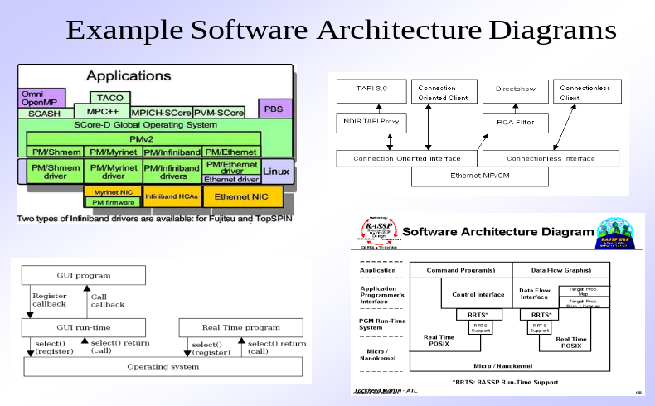
When we discuss the architecture of a building, many different attributes come to mind.
At the most simplistic level, we consider the overall shape of the physical structure.
But in reality, architecture is much more.
It is the manner in which the various components of the building are integrated to form a cohesive whole.
It is the way in which the building fits into its environment and meshes with other buildings in its vicinity.
It is the degree to which the building meets its stated purpose and satisfies the needs of its owner.
It is the aesthetic feel of the structure—the visual impact of the building—and the way textures, colors, and materials are combined to create the external facade and the internal “living environment.”
It is small details—the design of lighting fixtures, the type of flooring, the placement of wall hangings, the list is almost endless. And finally, it is art.
2.2.2 But what about software architecture?
It is defined in the following way:
The software architecture of a program or computing system is the structure or structures of the system, which comprise software components, the externally visible properties of those components, and the relationships among them.
The architecture is not the operational software.
Rather, architecture is a representation that enables a software engineer to
(1) Analyze the effectiveness of the design in meeting its stated requirements,
(2) Consider architectural alternatives at a stage when making design changes is still relatively easy, and
(3) Reducing the risks associated with the construction of the software.
In the context of architectural design, a software component can be something as simple as a program module, but it can also be extended to include databases and “middleware” that enable the configuration of a network of clients and servers.
The properties of components are those characteristics that are necessary to an understanding of how the components interact with other components.
At the architectural level, internal properties (e.g., details of an algorithm) are not specified.
The relationships between components can be as simple as a procedure call from one module to another or as complex as a database access protocol.
The design of software architecture considers two levels of the design pyramid (Figure 13.1)—
- Data design and
- Architectural design.
Data design enables us to represent the data component of the architecture.
Architectural design focuses on the representation of the structure of software components, their properties, and interactions.
2.2.3 Why Is Architecture Important?
Three key reasons that software architecture is important:
- Representations of software architecture are an enabler for communication between all parties (stakeholders) interested in the development of a computer- based system.
- The architecture highlights early design decisions that will have a profound impact on all software engineering work that follows and, as important, on the ultimate success of the system as an operational entity.
- Architecture “constitutes a relatively small, intellectually graspable model of how the system is structured and how its components work together” [BAS98].
The architectural design model and the architectural patterns contained within it are transferrable.
That is, architecture styles and patterns can be applied to the design of other systems and represent a set of abstractions that enable software engineers to describe architecture in predictable ways.
2.3 DATA DESIGN
Data design (sometimes referred to as data architecting) creates a model of data and/or information that is represented at a high level of abstraction (the customer/user’s view of data).
This data model is then refined into progressively more implementation-specific representations that can be processed by the computer-based system.
In many software applications, the architecture of the data will have a profound influence on the architecture of the software that must process it.
The structure of data has always been an important part of software design.
At the program component level, the design of data structures and the associated algorithms required to manipulate them is essential to the creation of high-quality applications.
At the application level, the translation of a data model (derived as part of requirements engineering) into a database is pivotal to achieving the business objectives of a system.
At the business level, the collection of information stored in disparate databases and reorganized into a “data warehouse” enables data mining or knowledge discovery that can have an impact on the success of the business itself.
2.3.1 Data Modeling, Data Structures, Databases, and the Data Warehouse
The data objects defined during software requirements analysis are modeled using entity/relationship diagrams and the data dictionary.
The data design activity translates these elements of the requirements model into data structures at the software component level and, when necessary, a database architecture at the application level.
In years past, data architecture was generally limited to data structures at the program level and databases at the application level.
But today, businesses large and small are awash in data.
It is not unusual for even a moderately sized business to have dozens of databases serving many applications encompassing hundreds of gigabytes of data.
The challenge for a business has been to extract useful information from this data environment, particularly when the information desired is cross functional (e.g., information that can be obtained only if specific marketing data are cross-correlated with product engineering data).
To solve this challenge, the business IT community has developed data mining techniques, also called knowledge discovery in databases (KDD), that navigate through existing databases in an attempt to extract appropriate business-level information.
However, the existence of multiple databases, their different structures, the degree of detail contained with the databases, and many other factors make data mining difficult within an existing database environment.
An alternative solution, called a data warehouse, adds an additional layer to the data architecture.
A data warehouse is a separate data environment that is not directly integrated with day-to-day applications but encompasses all data used by a business.
In a sense, a data warehouse is a large, independent database that encompasses some, but not all, of the data that are stored in databases that serve the set of applications required by a business.
But many characteristics differentiate a data warehouse from the typical database.
Differences between database and data warehouse:
Subject orientation: A data warehouse is organized by major business subjects, rather than by business process or function. This leads to the exclusion of data that may be necessary for a particular business function but is generally not necessary for data mining.

2.3.2 Data Design at the Component Level
Data design at the component level focuses on the representation of data structures that are directly accessed by one or more software components.
Wasserman [WAS80] has proposed a set of principles that may be used to specify and design such data structures.
In actuality, the design of data begins during the creation of the analysis model.
the set of principles for data specification:
- The systematic analysis principles applied to function and behavior should also be applied to data.
We spend much time and effort deriving, reviewing, and specifying functional requirements and preliminary design.
Representations of data flow and content should also be developed and reviewed, data objects should be identified, alternative data organizations should be considered, and the impact of data modeling on software design should be evaluated.
Example:
Specification of a multi ringed linked list may nicely satisfy data requirements but lead to an unwieldy software design.
An alternative data organization may lead to better results.
- All data structures and the operations to be performed on each should be identified.
The design of an efficient data structure must take the operations to be performed on the data structure into account.
Example:
Consider a data structure made up of a set of diverse data elements.
The data structure is to be manipulated in a number of major software functions.
Upon evaluation of the operations performed on the data structure, an abstract data type is defined for use in subsequent software design.
Specification of the abstract data type may simplify software design considerably.
- A data dictionary should be established and used to define both data and program design.
A data dictionary explicitly represents the relationships among data objects and the constraints on the elements of a data structure.
Algorithms that must take advantage of specific relationships can be more easily defined if a dictionary like data specification exists.
- Low-level data design decisions should be deferred until late in the design process.
A process of stepwise refinement may be used for the design of data.
That is, overall data organization may be defined during requirements analysis, refined during data design work, and specified in detail during component level design.
The top-down approach to data design provides benefits that are analogous to a top-down approach to software design—major structural attributes are designed and evaluated first so that the architecture of the data may be established.
- The representation of data structure should be known only to those modules that must make direct use of the data contained within the structure.
The concept of information hiding and the related concept of coupling provide important insight into the quality of a software design.
This principle alludes to the importance of these concepts as well as "the importance of separating the logical view of a data object from its physical view"
- A library of useful data structures and the operations that may be applied to them should be developed.
Data structures and operations should be viewed as a resource for software design.
Data structures can be designed for reusability.
A library of data structure templates (abstract data types) can reduce both specification and design effort for data.
- A software design and programming language should support the specification and realization of abstract data types.
The implementation of a sophisticated data structure can be made exceedingly difficult if no means for direct specification of the structure exists in the programming language chosen for implementation.
2.4 ARCHITECTURAL STYLES
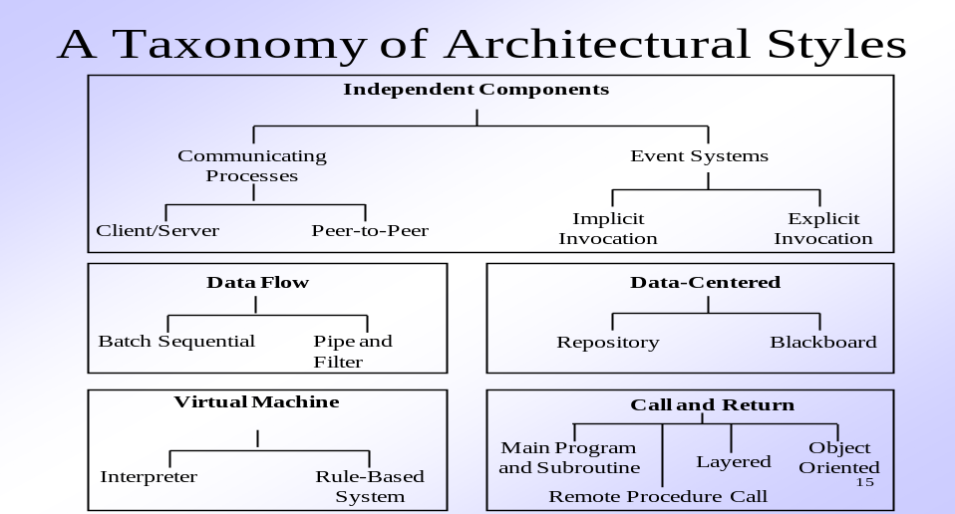
A Brief Taxonomy of Styles and Patterns
Computer-based systems can be categorized into following number of architectural styles:
2.4.1 Data-Centered Architectures.
A data store (e.g., a file or database) resides at the center of this architecture and is accessed frequently by other components that update, add, delete, or otherwise modify data within the store.

Figure 2.1 illustrates a typical data-centered style.
Client software accesses a central repository. In some cases the data repository is passive.
That is, client software accesses the data independent of any changes to the data or the actions of other client software.
A variation on this approach transforms the repository into a “blackboard” that sends notifications to client software when data of interest to the client change.
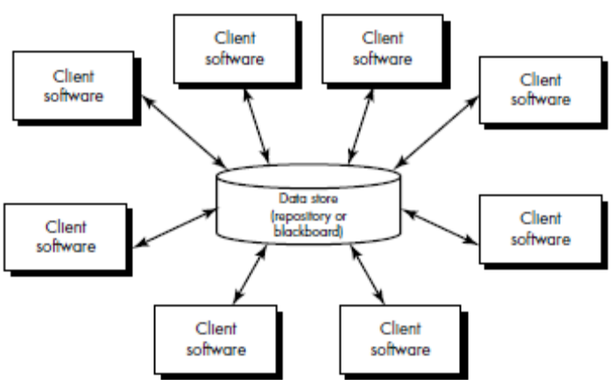
FIGURE 2.4.1 Data-centered architecture
Data-centered architectures promote integrability. That is, existing components can be changed and new client components can be added to the architecture without concern about other clients (because the client components operate independently).
In addition, data can be passed among clients using the blackboard mechanism (i.e., the blackboard component serves to coordinate the transfer of information between clients).
Client components independently execute processes.
2.4.2 Data-flow architectures.
This architecture is applied when input data are to be transformed through a series of computational or manipulative components into output data.
A pipe and filter pattern (Figure 2.4.2a) has a set of components, called filters, connected by pipes that transmit data from one component to the next.
Each filter works independently of those components upstream and downstream, is designed to expect data input of a certain form, and produces data output (to the next filter) of a specified form.
However, the filter does not require knowledge of the working of its neighboring filters.
If the data flow degenerates into a single line of transforms, it is termed batch sequential.
This pattern (Figure 2.4.2) accepts a batch of data and then applies a series of sequential components (filters) to transform it.
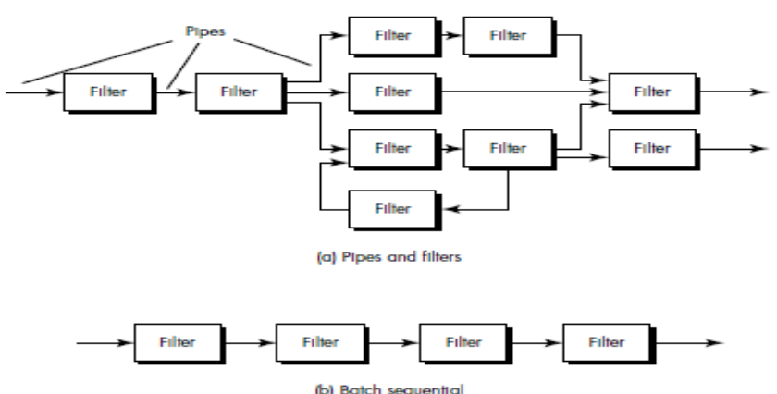
FIGURE 2.4.2 Data flow architectures
2.4.3 Call and return architectures.
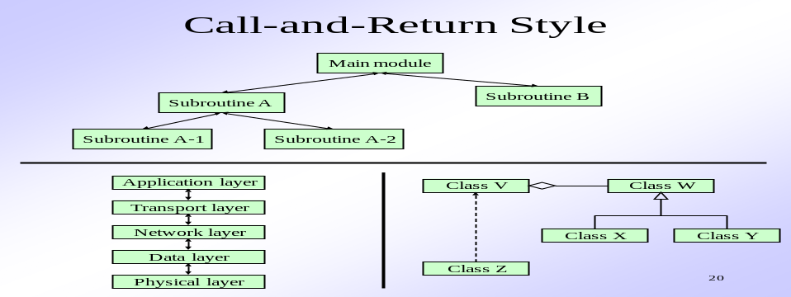
This architectural style enables a software designer (system architect) to achieve a program structure that is relatively easy to modify and scale.
Sub styles of this category:
- Main program/subprogram architectures.
This classic program structure decomposes function into a control hierarchy where a “main” program invokes a number of program components, which in turn may invoke still other components.
- Remote procedure call architectures.
The components of a main program/ subprogram architecture are distributed across multiple computers on a network
2.4.4 Object-oriented architectures.
The components of a system encapsulate data and the operations that must be applied to manipulate the data. Communication and coordination between components is accomplished via message passing.
2.4.5 Layered architectures.
The basic structure of a layered architecture is illustrated in Figure 2.4.3.
A number of different layers are defined, each accomplishing operations that progressively become closer to the machine instruction set.
At the outer layer, components service user interface operations.
At the inner layer, components perform operating system interfacing.
Intermediate layers provide utility services and application software functions.
These architectural styles are only a small subset of those available to the software designer.
Once requirements engineering uncovers the characteristics and constraints of the system to be built, the architectural pattern (style) or combination of patterns (styles) that best fits those characteristics and constraints can be chosen.
In many cases, more than one pattern might be appropriate and alternative architectural styles might be designed and evaluated.
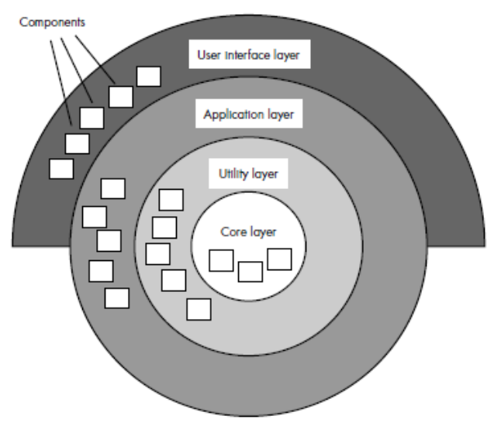
FIGURE 2.4.3 Layered architecture
.
2.5 REFINING THE ARCHITECTURAL DESIGN
Successful application of transform or transaction mapping is supplemented by additional documentation that is required as part of architectural design.
After the program structure has been developed and refined, the following tasks must be completed:
- A processing narrative must be developed for each module.
- An interface description is provided for each module.
- Local and global data structures are defined.
- All design restrictions and limitations are noted.
- A set of design reviews are conducted.
- Refinement is considered (if required and justified).
A processing narrative is (ideally) an unambiguous, bounded description of processing that occurs within a module.
The narrative describes processing tasks, decisions, and I/O. The interface description describes the design of internal module interfaces, external system interfaces, and the human/computer interface {Chapter 15).
The design of data structures can have a profound impact on architecture and the procedural details for each software component.
Restrictions and/or limitations for each module are also documented.
Typical topics for discussion include restriction on data type or format, memory or timing limitations; bounding values or quantities of data structures; special cases not considered; specific characteristics of an individual module.
The purpose of a restrictions and limitations section is to reduce the number of errors introduced because of assumed functional characteristics.
Once design documentation has been developed for all modules, one or more design reviews is conducted. The review emphasizes traceability to software requirements, quality of the software architecture, interface descriptions, data structure descriptions, implementation and test practicality, and maintainability.
Any discussion of design refinement should be prefaced with the following comment: "Remember that an 'optimal design' that doesn't work has questionable merit."
The software designer should be concerned with developing a representation of software that will meet all functional and performance requirements and merit acceptance based on design measures and heuristics.
Refinement of software architecture during early stages of design is to be encouraged.
As we discussed earlier in this chapter, alternative architectural styles may be derived, refined, and evaluated for the "best" approach.
This approach to optimization is one of the true benefits derived by developing a representation of software architecture.
It is important to note that structural simplicity often reflects both elegance and efficiency.
Design refinement should strive for the smallest number of modules that is consistent with effective modularity and the least complex data structure that adequately serves information requirements.

